How to make the report Analytics report prompt input be case insensitive | 

Yoel Kortick
Senior Librarian

There may be cases where a user will input data to a prompt, such as a “word from title”.
The data on which this input will search might sometimes include uppercase and sometimes lowercase.
In a situation like this we will not want the user to enter in the prompt a word such as “Computer” (with a capital C) if the title only contains lowercase “computer”.

In a situation like this we can take the input of the user from whatever she or he enters in the prompt and make it lowercase (or when necessary uppercase), and have it search a lowercase version of the title (or any other field). This way the term the user searches and the data being searched will both be in the same case. This is what we will show here.

ONE
From the “Prompts” column of the report add a new prompt and choose “Variable Prompt”

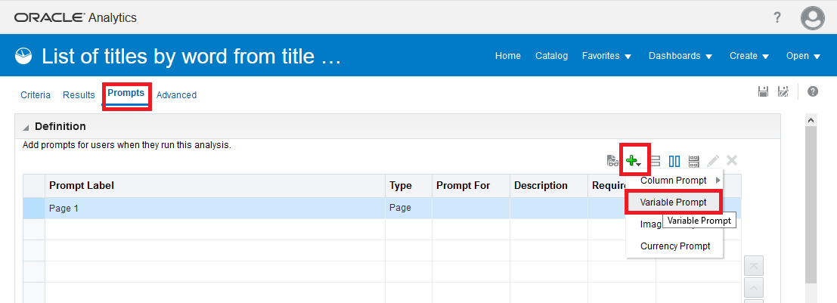

TWO

When defining the prompt
- Choose “Prompt for” “Presentation Variable”
- Enter a name for the variable with no spaces. We will name it “word_from_title”.
- Give it a desired logical label
- Define the user input as a text field

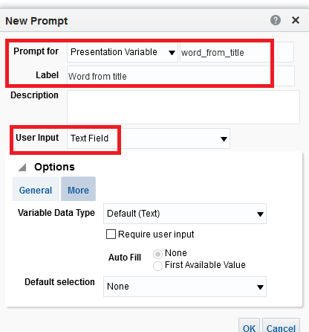

THREE

We will convert the text the user enters in the prompt to lowercase and also make the title be lowercase.

Both the prompt text and the test of the title will be converted to lowercase and thereforew it will not matter if they were origonally uppercase or lowercase. A search for “Computer” will find text “computer.”

To make the title be lowercase do “edit formula” on ther title and change
"Bibliographic Details"."Title"
To
lower("Bibliographic Details"."Title")

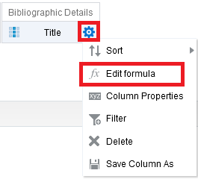

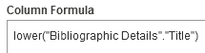

FOUR

From the criteria tab of the report create a filter on the lowercase field which will match the text entered by the user, and click “convert this filter to SQL”.

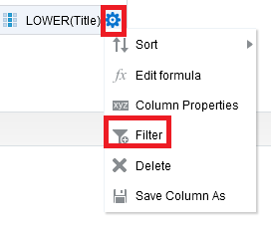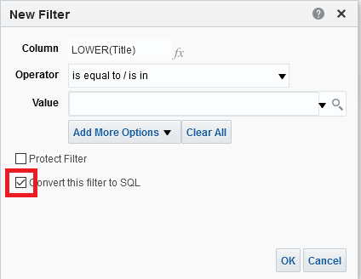

In the SQL make the field you chose for the filter be LIKE the uppercase or lowercase of the name of the presentation variable. For example, because
- We are using field lower("Bibliographic Details"."Title")
- This field is all lowercase
- We named our Presentation Variable “word_from_title”

We will have this text:

lower("Bibliographic Details"."Title") LIKE LOWER('%@{word_from_title}%')

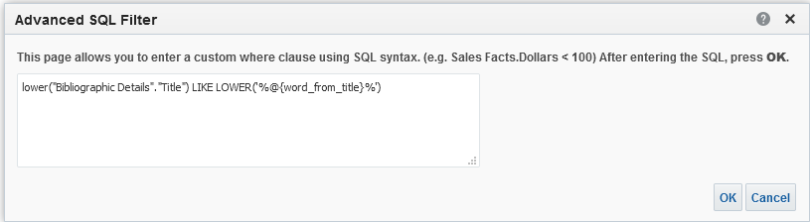

FIVE

We will display the regular title and filter by the lowercase title.

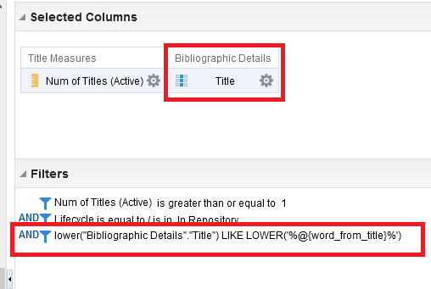

SIX

Now we will run the report and fill in the text as Computer (just to make sure it really will work regardless of case entered). We see results with “Computer” and “computer”.

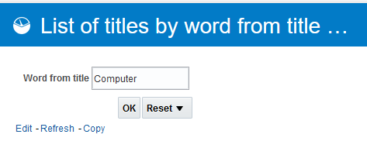

We see correct results. Sometimes there is “Computer” and sometimes “computer”.

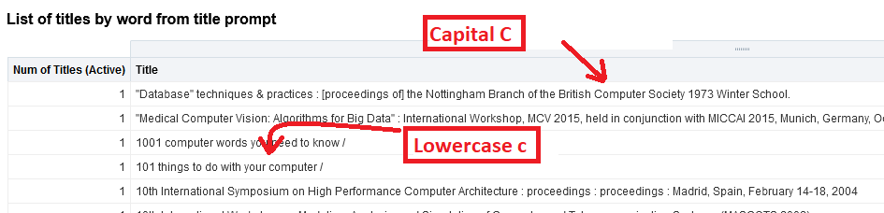

SEVEN

Note that there are also cases where we might not want to use the percent signs around the value from the prompt.
The percent signs in ('%@{word_from_subject}%') mean that the words may or may not have other values before or after. For example “computer” could find “computers”, “computerized” and “supercomputer”.

